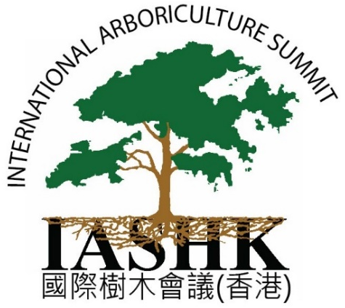
IAS-HK 2019 Registration Form
Hong Kong, November 13-15, 2019
Thank you for your interest, and we look forward to seeing you at the conference! Please send your registration form, required documentary proof for registration discounts, and payment to our address or scan and email to: info@ias.hk

Please note the registration schedule deadlines

Three Day Registration (Full Summit)
 | Standard Attendee | Previous Attendee | ISA or HKILA Members | Students & Faculty of VTC |  | Students & Faculty of Other Institutions  in HK or Abroad
 |  |  |  | Students | Faculty | Students | Faculty
Before 25 October | HK$3960 | HK$3740 | HK$3590 | HK$300 | HK$1000 | HK$1500 | HK$1980
26 Oct – 6 Nov | HK$4290 | HK$3990 | HK$3850 | HK$500 | HK$1200 | HK$1800 | HK$2200
After 6 Nov | HK$4500 |  |  | HK$500 | HK$1200 | HK$1800 | HK$2200

Individual Day Registration
 | Standard Attendee | Previous Attendee | ISA or HKILA Members | Students & Faculty of VTC |  |  |  | Students & Faculty of Other Institutions  in HK or Abroad
 |  |  |  | Students |  | Faculty | Students |  | Faculty
Before 25 October | HK$1980 | HK$1890 | HK$1690 | HK$100 |  | HK$400 | HK$800 |  | HK$1000
26 Oct – 6 Nov | HK$2100 | HK$1990 | HK$1890 | HK$200 |  | HK$500 | HK$900 |  | HK$1200
After 6 Nov | HK$2400 |  |  |  | HK$200 | HK$500 | HK$900 |  | HK$1200

This year lunch will not be provided.
Lunch options are available both on campus and off campus nearby.

Discounts
Please read all options and select one option only

Previous Summit Attendee *IAS-HK Summit Attendees only
Vocational Training Council Students *send documentary proof with registration
Any Faculty of VTC or Other & Students of Other Institutions *send documentary proof with registration
Memberships of HKILA or ISA (any chapter or ISA HQ) *send documentary proof with registration
These offers expire 1 November 2019

Days of Attendance
Please specify which days you will attend: November 13 14 15 6

Total sum including any discounts or early registration:

Registration Information
For multiple attendees, please submit an Excel spreadsheet with the following information (all fields are required):

Full Name:
Name for Conference Badge: Company/Organization:
Address:
City: Phone: Fax:
Email: __________________________ your confirmation email and instructions will be sent to this address.
ISA Certification Number (if applicable): * we must have this number for CEU applications

Policies
- Registration is considered complete once payment has been received in full.
- We reserve the right to change the program outline and/or venue if due to circumstances beyond our control.
- Cancelation of registration will be refunded at 90% up to 1 Nov. (Thereafter, no refund will be returned in the case of cancelation)
- Attendees may not elect others to attend in their place unless requested and confirmed 3 weeks in advance via email, fax, or mail
- ID is required for Full-Time Students during attendance

Payment Methods
By Wire Transfer (TT) or Direct Deposit  * Please email info@ias.hk with a scanned copy of the deposit receipt once deposited  * All wire transfer fees must be paid by the payer (remitter)  Institute of Arboriculture Studies (HK) Ltd.  Bank: HSBC  Acct: 561-793092-001  Swift Code: HSBCHKHHHKH | By Cheque Payment  * Please mail the cheque along with the registration form to the following address  Institute of Arboriculture Studies (HK) Ltd.  1302 Wah Yiu Industrial Center  30-32 Au Pui Wan Street  Sha Tin, NT  Hong Kong
By Online Credit Card Payment
Go to our website and complete the registration and online payment process. www.ias.hk

