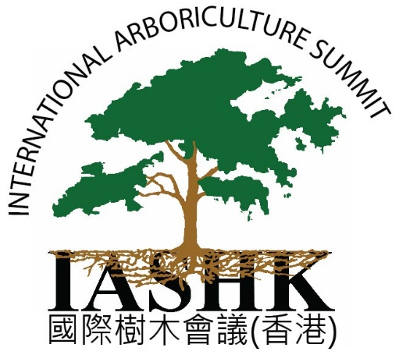

IAS-HK 2018 Registration Form
Hong Kong, November 14-16, 2018

Thank you for your interest, and we look forward to seeing you at the conference! Please send your registration form, required documentary proof for registration discounts, and payment to our address or scan and email to: info@ias.hk
Please note the special discounts offered for attendance, as well as the registration schedule deadlines

3 Day (Full Summit) Registration *
Registration Periods | Standard Attendance | Previous Attendee | HKILA or ISA Member  ** | Vocational Training Council Students | Any Faculty & Students of Other Institutions***
Early - Until 19 October | HK$3960 | HK$3740 | HK$3590 | HK$300 | HK$1000
Standard - 20 Oct – 2 Nov | HK$4290 | HK$3990 | HK$3850 | HK$500 | HK$1200
Full Registration After 2 Nov | HK$4500 |  |  | HK$500 | HK$1300
* Substantial savings when registering for the full 3-day summit.
** ISA Membership refers to any ISA membership of any chapter or ISA HQ.
*** Faculty of VTC or other institution offered very low rate (Students Outside of Hong Kong are 50% off)

1 Day Summit Only
Registration Periods | Standard Attendance | Previous Attendee | HKILA/ISA  Member* | Vocational Training Council Students | Any Faculty & Students of Other Institutions**
Early - Until 19 October | HK$1980 | HK$1890 | HK$1690 | HK$100 | HK$500
Standard - 20 Oct – 2 Nov | HK$2100 | HK$1990 | HK$1890 | HK$200 | HK$600
Full Registration After 2 Nov | HK$3300 |  |  | HK$200
* ISA Member refers to any membership wherever you are located
**Faculty of VTC or any institution offered very low rate (Students Outside of Hong Kong are 50% off)

Due to last year’s attendee evaluation form results, this year lunch will not be provided.
Options are available both on campus and off campus nearby.

Special Discounts
Please read all options and select one option only

Previous Summit Attendee (does not include previous attendance to other workshop or events)
Offered to previous attendees of IASHK conferences only. (does not include previous TRAQ or other seminars)
Vocational Training Council Students *send documentary proof
Must also send documentary proof of full time enrollment, offer expires 4 November
Any Faculty of VTC or Other & Students of Other Institutions *send documentary proof
Memberships of HKILA or ISA (any chapter or ISA HQ) *send documentary proof
Students outside Hong Kong are 50% off *send documentary proof
These offers expire 4 November

Notes and Policies: *please read
* Please note the substantial savings when registering for the full 3-day summit
**Members of the Hong Kong Institute of Landscape Architects (HKILA) or International Society of Arboriculture (ISA) receive a substantial and generous educational benefit from the Institute of Arboriculture Studies Hong Kong (IASHK)
- Please choose the registration type that is applicable to you. Only one registration type may be chosen.
- Registration is considered complete once payment has been received in full.
- We reserve the right to change the program outline and/or venue if due to circumstances beyond our control.
- Cancelation of registration will be refunded at 90% up to 2 Nov. (Thereafter, no refund will be returned in the case of cancelation)
- Attendees may not elect others to attend in their place unless requested and agreed to 2 weeks in advance of the event
- ID is required for Full-Time Student and Memberships proof of status.

Registration Information
For multiple attendees, please submit in Excel with the following information (all fields are required):

Full Name: HKILA/ISA Certification Number:

Name for Conference Badge: _______ Company/Organization: _______

Address:

City: Phone: Fax:

Email: __________________________ your confirmation email and instructions will be sent to this address.
Please specify which days you will attend: November 14 15 16 6

Total sum including any discounts or early registration: ___________________________________

Please note that registration is only complete once payment is received. See next page for payment methods.

Methods of Payment
By Wire Transfer (TT) or Direct Deposit  *Please email info@ias.hk with a scanned copy of the deposit receipt once deposited  *All wire transfer fees must be paid by the payer (remitter)  Institute of Arboriculture Studies (HK) Ltd.  Bank: HSBC  Acct: 561-793092-001  Swift Code: HSBCHKHHHKH | By Cheque Payment  *Please mail the cheque along with the registration form to the following address  Institute of Arboriculture Studies (HK) Ltd.  1302 Wah Yiu Industrial Center  30-32 Au Pui Wan Street  Sha Tin, NT  HONG KONG
By Online Credit Card Payment
Go to our website and complete the registration and online payment process. www.ias.hk
Direct Link: https://www.ias.hk/product-category/seminar-registration/

